Join a Datto NAS to a Windows Domain
- Login to the Datto BCDR Status Dashboard
- Locate your Datto appliance and click on the Device Web Arrow:
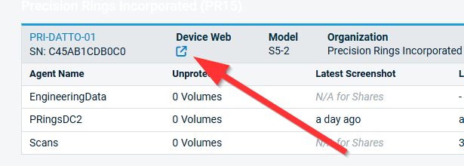
- At the top menu, click on Configure and then select Networking:

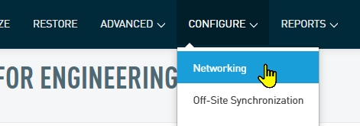
- Under the Settings menu on the left, click on the Windows Networking option:
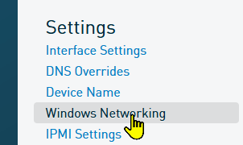
- Scroll down to the DNS Overrides section and fill out all 4 fields as follows:
  - SERVER 1: Primary domain controller IP
  - SERVER 2: Secondary domain controller IP
  - SERVER 3: Public DNS such as Cloudflare (1.1.1.1)
  - DNS Search Domains: Enter your domain including the .local, such as domainname.local

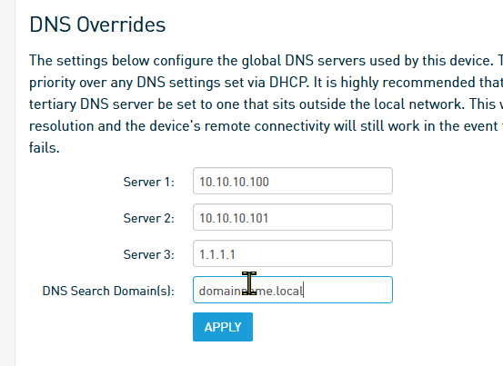
- Click on the Apply button
- Next, scroll down to the Windows Networking – Workgroup section
- Click on Join a Domain button
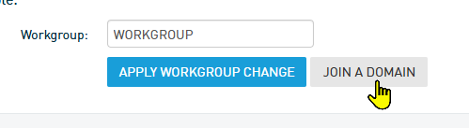
- Fill out the Windows Networking - Workgroup section as follows:
  - DOMAIN: domainname.local
  - Username: impactadmin (your domain admin username)
  - Password: your domain admin user name
  - Password Server: PDC IP address (this step is critical)

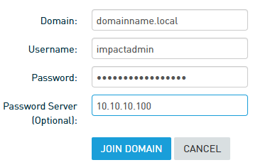
- Lastly, click on Join Domain. If you followed the above instructions correctly, your appliance will now be part of your Windows domain.

